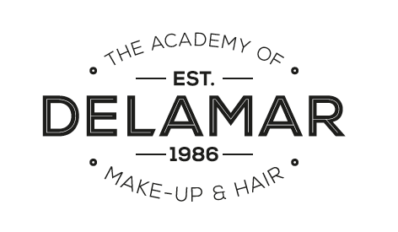

This is to certify that

Emily Gordon

has attended and successfully completed the:

Advanced Complete Make-up Artist Course

9th January 2012 to 8th June 2012

Course tutors: Nikki Hambi, Sallie Jaye, Emma Jones, Amanda Warburton, Jo Neilson, Laura Solari, Deb Taylor, Raphaelle Fieldhouse, Andy Deubert, Pascal Marin, Astrid Kearney, Lisa Hilton, Thomas Cornell and Tracey Lee

Signed:
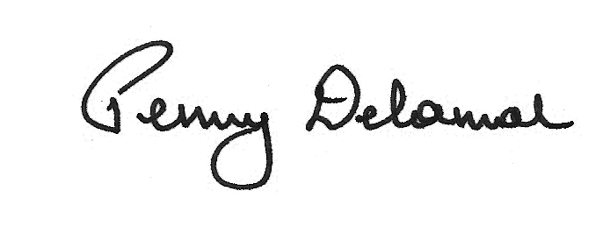

Date: 13th June 2017

Ealing Studios, Ealing Green, London W5 5EP.
Tel: 020 8579 9511 email: info@delamaraademy.co.uk website: www.delamaracademy.co.uk

